# User model

This diagram is the workflow net model for the user part. Based on the skills of Modeling Information System, to describe the behavior of user, this workflow net can clearly show how user can use the functions of our website.

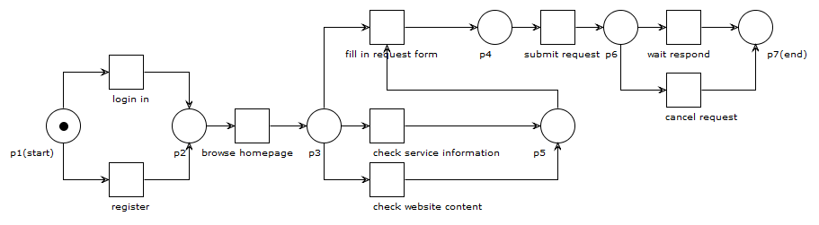

# Staff model

This diagram is the workflow net model for staff part. Based on the skills of Modeling Information System, to describe the behavior of staff, this workflow net can clearly show how staff to solve the request from users and communicate with each service providers.

